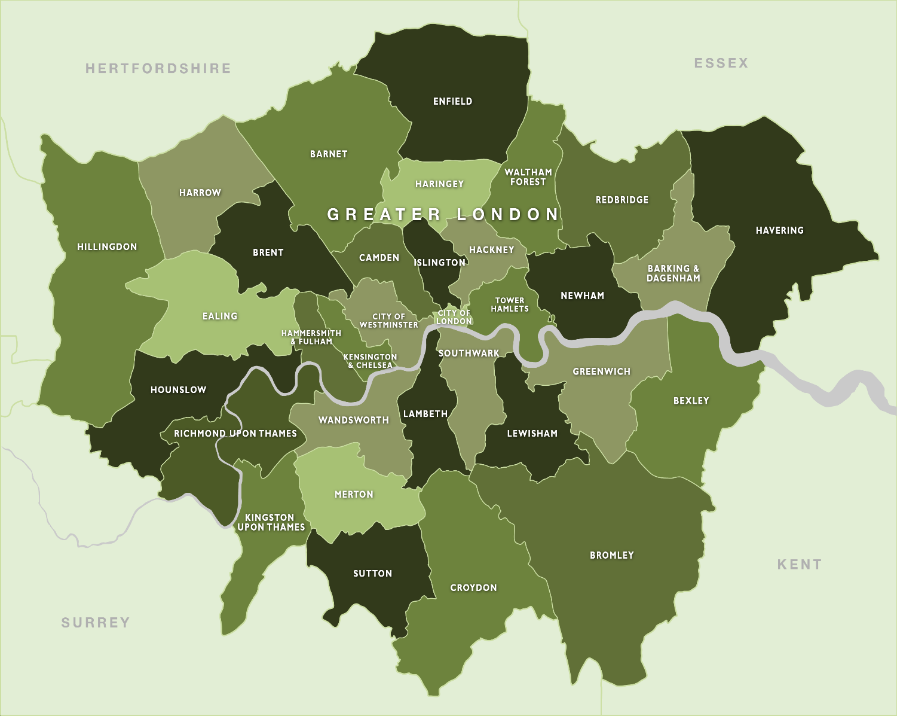
WEST LONDON
Low Carbon Procurement Policy - October 2021
West London Low Carbon Procurement Policy
- Introduction and Vision
- It is widely agreed that there is a climate crisis, and that every organisation should work towards reducing its carbon impact to net zero by 2050. The eight local authorities in West London – Brent, Ealing, Hammersmith & Fulham, Harrow, Hillingdon, Hounslow, Richmond upon Thames, and Wandsworth – and West London Waste (together the ‘Participating Authorities’) - are no different and each has made a commitment to reduce our emissions and address related social and environmental impacts.
- We spend millions of pounds annually on the procurement of goods, services and works. The approach we take in spending our budgets has a direct and significant impact on the community we work for and hence we have a great responsibility and opportunity to create positive carbon outcomes from that spend.
- We have agreed that, in pursuing low carbon outcomes from the commissioning, planning & design of services, procurement, contract management, and delivery of all our services, we will collaborate in our efforts in a coordinated and consistent fashion in order to further alleviate negative impacts on the environment, society, and the community in which we operate.
- This Low Carbon Procurement Policy sets out the commitment of the eight local authorities and West London Waste and the general principles we will follow across all our procurement and commissioning activities to ensure that it is undertaken to deliver sustainable procurement at value for money across the life of the contract / or whole life costs.
- Doing so, we will play our part in addressing the issue of climate change and reduction of carbon emissions within supply chains to work towards UK’s Net Zero target.
- The Policy also recognises the associated benefits from simultaneously addressing the impacts of poor air quality, enhancing biodiversity, improving the health and wellbeing of residents, moving to a more circular economy, driving increased investment in the eight boroughs, encouraging innovation, and developing local skills. In aiming to reduce our carbon emissions, we strive to address these related impacts and opportunities as well.
- Furthermore, the Policy aims to drive consistency and action on carbon reduction across the eight local authorities and, while each local authority will carry out procurement independently, the policy advocates a commitment to a common and collaborative approach where possible.

- Background
- Formed in 1997, the West London Alliance is a partnership that includes the local authorities of Brent, Ealing, Hammersmith & Fulham, Harrow, Hillingdon, and Hounslow. In September 2020, following approval by the West London Economic Prosperity Board, the West London Alliance published their Build & Recover Plan. The Plan places a strong emphasis on a green recovery and includes a commitment to “Use our status as ‘anchor institutions’ to lead by example by making our procurement policies more favourable to low carbon suppliers”. In addition, each of the Participating Local Authorities have formally declared a Climate Emergency with a commitment to work towards carbon neutrality / net-zero by 2030.’
- This Policy recognises the importance of the Participating Authorities’ supply chains to reducing our organisational emissions and working towards our targets. We recognise that achieving those reductions needs the collaboration, continued support, and involvement of our supply chain through the procurement process.

- This document is intended for:
- Councillors – to lead, challenge and monitor the way we carry out procurement.
- Senior Management Teams – to manage the Participating Authorities’ adherence to the objectives we have set for ourselves and ensure that proposed improvements happen.
- Procurement – so they can be clear about the Participating Authorities’ objectives and shape their procurement activities accordingly.
- Commissioners (Internal Client) – to ensure the commitment of the Participating Authorities towards net zero 2030 is reflected in the specification for procurement.
- Delivery Contract Managers – to ensure the supply chain commitments made during the tender stage are realised by effective supplier performance and relationship management.
- Suppliers and potential suppliers – to understand the Participating Authorities’ expectations and to provide SMART solutions to deliver our goals.
- Strategic Suppliers – so we can better work together to align our policies and strategic direction.
- And most importantly for our residents and local stakeholders – to be aware of the direction the Participating Authorities are taking.

- Scope
- The policy covers all areas of commissioning and procurement cycle, irrespective of contract value and duration, within the Participating Authorities and will influence the way we procure goods, works and services.
- For procurement below a given value threshold (refer to local authority procurement strategy for individual thresholds), due regard should be given to the resources available to smaller providers which may bid for lower value procurement. Requirements will also apply to major sub-contractors.
- It includes local and global impacts, and applies to the procurement of goods, works and services including use, refurbishment and decommissioning of goods and materials as applicable.
- Notwithstanding the above, each authority will maintain their own, local discretion on how to deliver the carbon outcomes desired by the Participating Authorities.

- Purpose
The purpose of this Policy and the associated climate action plans is to:
- Enable procurement and commissioning to contribute to the Participating Authorities’ overall vision to deliver improved outcomes for West London and to provide efficiencies to help deliver its key priorities and provide services for its residents. These include net zero carbon and related impacts of biodiversity net gain, local air quality, circular economy, and social value.
- Provide a framework for the Participating Authorities’ to develop a plan to achieve continuous climate change improvement in its commissioning and procurement activities.
- Ensure compliance with relevant legislation, policies, and procedures.
- Go beyond compliance to maximise benefits achieved by going on step further.
- Ensure consistency in approach across the Participating Authorities to Net Zero objectives.

- Objectives
The key objectives of our Policy are to make procurement:
- Consistent – to ensure a unified approach of agreed excellence in relation to carbon reduction across the Participating Authorities, bringing the benefit of a joined-up approach to the supply chain.
- Responsible – to use commissioning and procurement to strengthen the Alliance environmentally and socially.
- Accountable – accountability for impacts generated by in-house services and those by our supply chains, with a life cycle perspective on works, goods or services.
- Respect our stakeholders – and their interests for a greener, safer, healthier environment for now and future generations.
- Transparent – in our procurement decisions and activities and encouraging the same of our supply chains as a basis for collaborative working relationships, using our Low Carbon Procurement Toolkit.
- Measurable – using the Low Carbon Procurement Toolkit to measure how we are performing in reducing the carbon associated with procurement and supply chain.
- Continually Improve – in support of achieving this target we have set.
- Analyse all costs – consider the cost incurred over the life cycle, value for money achieved, and the costs and benefits for society, the environment and the economy resulting from its procurement activities.

- Our Supply Chain
To bring our supply chain along with us on this journey, we will:
- Incorporate action on climate change into our procurement and tendering, asking questions of all categories of supplier markets, proportionate to the supplier business size and relevant to the sustainability topic and impact, to ensure contracted suppliers over time are making a positive and progressive contribution to reducing carbon emissions.
- Expect existing suppliers to embed climate change initiatives into their current service contracts and tendering processes.
- Expect new suppliers to incorporate this vision and support this outcome as part of their tender bid, contract award and delivery process.
- Engage with our supply chains to go beyond compliance and contractual requirements.
- Implement supplier development plans to support suppliers individually to develop their capabilities over time, including sustainability.
- Be coordinated in our approach and support in development of innovation and capability within the supply chain.
- Initiate capacity building programmes to improve alignment between the Participating Authorities and their suppliers.

- West London Boroughs’ Priorities
To deliver on our vision, we need to work alongside our supply chain partners. To set the direction, we have identified our priorities as: implementing Climate Action Plans; Measuring and Monitoring Progress; Providing Training and Support; Encouraging Innovation; Working collaboratively; and communicating to our stakeholders.
To evidence success against our set priorities, we have outlined objectives that sit under each of them. These objectives will be incorporated into our decision-making process with the supply chain and form a central part of our procurement procedures.
- We will communicate our drivers and goals in the procurement process. The climate action plans set the route for our area to make the transition to net zero have been developed by the Participating Authorities. Including these in our tender documents and other market engagement channels ensures we communicate our plans to the supply chain.
- We will ensure there is support for those responsible for the commissioning and procurement of works, goods and services, to build their sustainable procurement capability and capacity to deliver net zero within procurement teams. We will also support and encourage upskilling of our key suppliers and contractors in this area. The ability to address and reduce the impacts from carbon and other related sustainability impacts needs to be embedded in the whole authority, across staff and systems.
- We will encourage innovative, sustainable solutions from our supply chain, through the procurement process, market engagement, prequalification, tender stage, and post award of contract to support us in delivering our carbon targets.
- We will collaborate with our wider stakeholders, such as affiliated local authorities, the Ministry of Housing, Communities and Local Government (MHCLG), the Local Government Association (LGA), London Councils and other key delivery bodies, on developing and delivering strategies which ensure a systematic transformation in line with achieving net zero carbon.
- We will collect performance data from our internal functions and supply chains and use this data to manage performance, monitor and report on progress in reducing emissions.

- Delivery of this Policy
- The delivery of our vision and key commitments which form part of this Policy for the West London Boroughs are reflected within the climate actions plans of the Participating Authorities. Our approach for delivery will be holistic and will encompass provision of relevant training, working with various stakeholders, including elected Members and officers of the Council, as well as our customers and suppliers to enhance our existing processes and documents for procurement and contract management. In addition, relevant tools for capturing results and monitoring progress of achievement of our objective will be put in place and our achievements, will be widely communicated within the Participating Authorities and externally.
- It is important that we define clear environmental benefits in our procurement in a way that is practicable and proportionate to the value and complexity of each individual contract. The outputs and outcomes that we set and agree with our suppliers will be realistic and we will be proactive with regards to how we track our progress, making sure that the outcomes are realised and captured.
- We will deploy a Low Carbon Procurement Toolkit (including an agreed form of Charter to be sent to existing and prospective suppliers) that will describe and define our approach to procuring low carbon solutions in the works, products, and services we source from the supply chain.

- Governance
- Reporting against the vision and target set out in this policy will be done at local authority level, based on the individual climate action plans.
- This Policy is a live document and will be reviewed and updated annually on the recommendation of the Participating Authorities’ Low Carbon Procurement Working Group to reflect current legislation, advances in UK governments targets, and other factors directly relevant to the vision and its outcomes.
Appendix A – Link to Documents (climate action plans or strategies of the WLA local authorities)
- Brent
- Declaring a Climate and Ecological Emergency
- Brent Council Anti-Idling guidance for Vehicles
- Brent Climate & Ecological Emergency Strategy
- Procurement Sustainability Policy
- Brent Long Term Transport Strategy

- Hounslow
- Hounslow Climate Emergency Action Plan (CEAP)
- The Green Recovery Strategy (Titled: Stimulating A Green Recovery)
- Contract Procedure Rules

- Hillingdon
- Hillingdon Council declares a climate change emergency - Hillingdon Council
- Climate change consultation - Hillingdon Council
- Strategic Climate Action Plan

- Ealing
- Climate Declaration / Carbon strategy
- Sustainable Procurement Policy Statement

- Richmond
- Climate Emergency Strategy
- Richmond Climate Emergency Strategy & Emergency Plan 2021

- Wandsworth
- Wandsworth Environment and Sustainability Strategy
- Wandsworth Environment and Sustainability Strategy 2021

- Hammersmith and Fulham
- Carbon Audit: results and Recommendations
- London Borough of Hammersmith & Fulham’s Social Value Strategy
- H&F 2030: Climate and Ecology Strategy

- Harrow
  - London Borough of Harrow Climate Change Strategy Incorporating the Air Quality and Climate Change Action Plans, 2019 – 2024
  - The Climate and Ecological Emergency –Harrow’s Interim Strategy and actions

- West London Waste
- WLWA Carbon Plan
- WLWA Procurement Rules

https://wla.london/
2020-September-Build-and-Recover-Plan.pdf (wla.london)
https://www.gov.uk/government/organisations/ministry-of-housing-communities-and-local-government
https://www.local.gov.uk/
About Climate Change | London Councils

